In this lab, we will develop different layouts and use different widgets.

**Basic Widgets**

* **TextView**: Displays text to the user.
* **EditText**: Allows users to input text.
* **Button**: A clickable button that performs an action.
* **ImageButton**: A button with an image instead of text.
* **ImageView**: Displays an image or drawable.
* **CheckBox**: A checkbox for binary choices.
* **RadioButton**: Used in groups for single-selection choices.
* **ToggleButton**: A button with an on/off state.
* **Switch**: A modern on/off toggle switch.

**2. Layout Widgets**

* **LinearLayout**: Arranges child views in a single row or column.
* **RelativeLayout**: Positions child views relative to each other or the parent.
* **ConstraintLayout**: A flexible layout for creating complex UIs with constraints.
* **FrameLayout**: Stacks child views on top of each other.
* **GridLayout**: Arranges child views in a grid.
* **TableLayout**: Arranges child views in rows and columns (like a table).

activity_main.xml will have six buttons one for each layout type When a button is clicked it will open the corresponding activity with its layout showing.

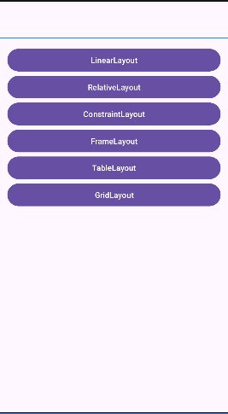

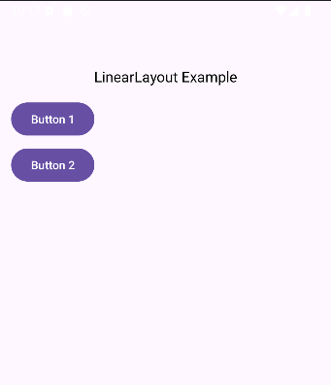 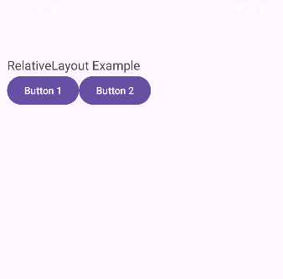 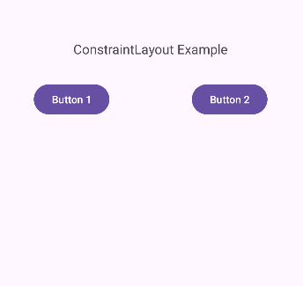

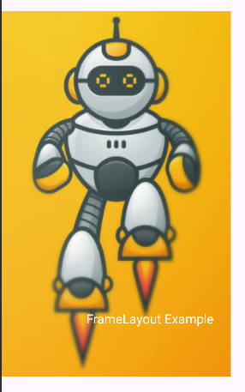 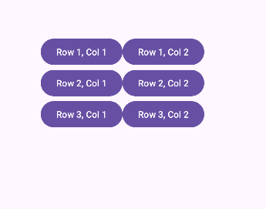 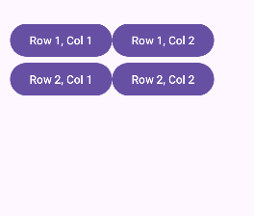

* Start a new application (Empty Views Activity)
* Create new activities, one for each layout type

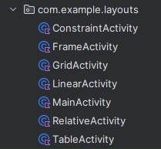

Lets first create ConstraintActivity.kt  
  
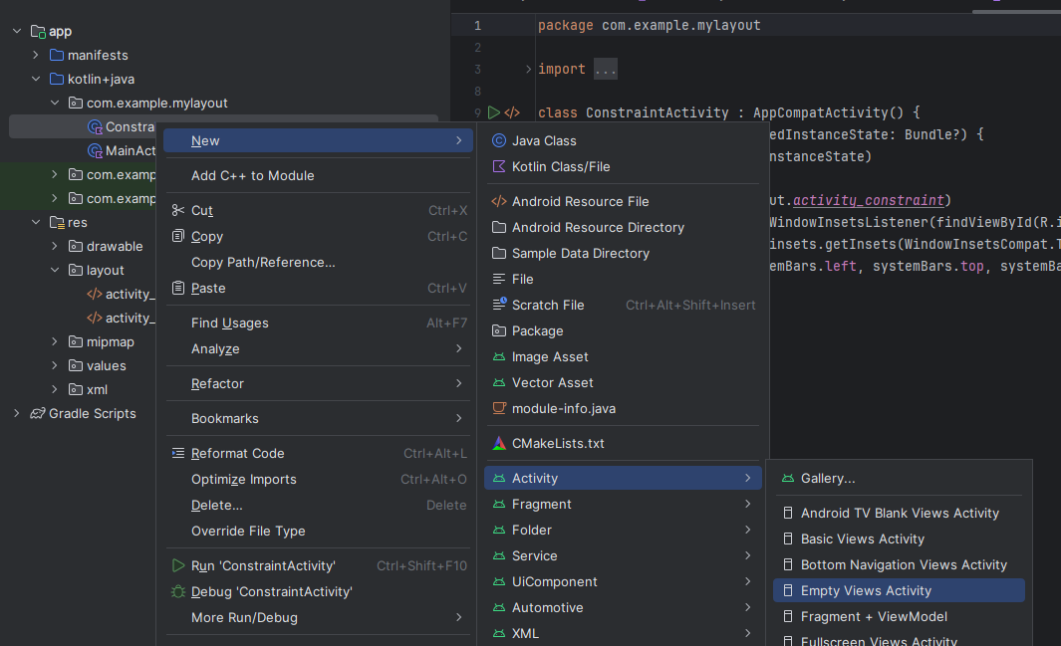

* Note the layout files are created automatically and activity is added to AndroidManifest
* We have seven activities and seven layout files once they are all added
* Copy the layout headers from Android Studio UI widgets.doc to corresponding layout files except activity_constraint.xml which has the correct headers. activity_main has a linear layout
* MainActivity.kt

class MainActivity : AppCompatActivity() {  
 override fun onCreate(savedInstanceState: Bundle?) {  
 super.onCreate(savedInstanceState)  
 setContentView(R.layout.*activity_main*)  
  
 findViewById<Button>(R.id.*btnRelative*).setOnClickListener **{** startActivity(Intent(this, RelativeActivity::class.*java*))  
 **}** findViewById<Button>(R.id.*btnConstraint*).setOnClickListener **{** startActivity(Intent(this, ConstraintActivity::class.*java*))  
 **}** findViewById<Button>(R.id.*btnFrame*).setOnClickListener **{** startActivity(Intent(this, FrameActivity::class.*java*))  
 **}** findViewById<Button>(R.id.*btnTable*).setOnClickListener **{** startActivity(Intent(this, TableActivity::class.*java*))  
 **}** findViewById<Button>(R.id.*btnGrid*).setOnClickListener **{** startActivity(Intent(this, GridActivity::class.*java*))  
 **}** findViewById<Button>(R.id.*btnLinear*).setOnClickListener **{** startActivity(Intent(this, LinearActivity::class.*java*))  
 **}** }  
}

* Put four widgets in each page, copy and paste the CODE and screen capture of the EMULATOR  
    
  Relative Layout

Constraint Layout

Table Layout

Frame Layout  
  
  
  
Grid Layout  
  
  
  
  
Linear Layout